St r Playschool
& Nursery
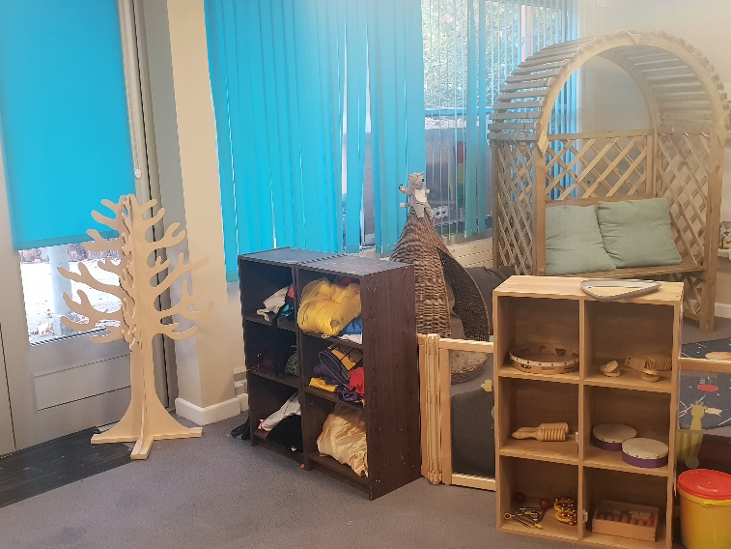
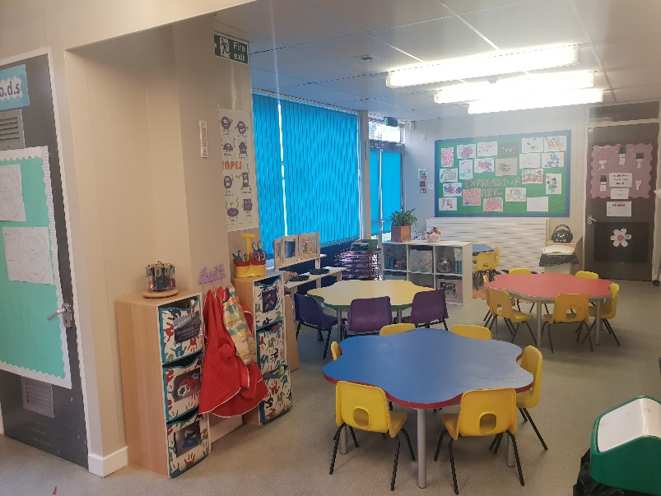
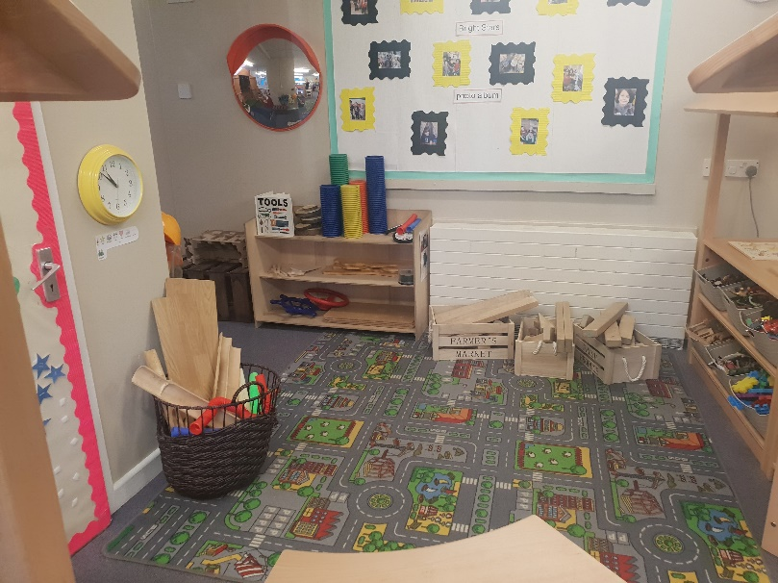
Prospectus

Welcome to Star Playschool and Nursery
VISION
Every child is unique, we encourage individuality and choice, create a nurturing environment and form excellent relationships with parents and carers.

In order to fulfil our vision, we will…
Ensure that all parents/carers are valued as the most important people in caring for and educating their child/ren and we will celebrate each child as an individual.
We will achieve this by…
- Creating an environment which promotes inclusion by introducing appropriate resources and positive images of gender, disability, ethnic minorities and different cultures
- Treating all children as individuals, observing and planning activities tailored around their interests
- Encouraging the participation of parents and carers in all aspects of the running of the nursery
- Creating a welcoming atmosphere which makes the child, parents and carers happy and comfortable within the nursery
- By developing and maintaining strong links with the local community, children’s centres and other agencies, encouraging the local community and these professionals to play an active role within the setting.

The staff team look forward to working with you and your family.

Management
Meet the Staff
Gemma burrows
Manager/DSL

Danielle Oates
Deputy Manager/
DDSL/SenCo

Twinkle Stars
Mary Davies
Room Leader/Eolo
3rd in charge

Michelle Oates
Nursery Practitioner

Shooting Stars
Siobhan Oates
Room Leader

Julie Marsh
Practitioner/H&S
Phillip Partridge
Practitioner/Fire Officer

Siobhan Armstrong
Practitioner

Bright Stars
Sarah Gibbins
Room Leader
BeCo

Jemma Syrett
Practitioner

Amy Blight
Practitioner

Alexis Snozwell
Practitioner

Settling in your children

At Star Nursery, we know that leaving your child can be a very difficult time. That is why we aim for your children to feel safe, stimulated and happy within the nursery before you leave them for their first session, whilst also aiming for you as parents to have confidence in both your child’s well-being and your role as active parents.
We will work alongside you and your family to ensure that your child is completely happy is his/her nursery environment before you leave them with us.
By being flexible with visit lengths and frequencies, we can ensure that your child will get to know staff and children on their own terms and we will endeavour to welcome you as a family into our establishment.
Our policy states that your child has a minimum of 2 pre-visits before their start date and if we feel your child is not settling we will arrange a gradual approach during this transition, e.g. your child may attend nursery for 1 hour each session and you will be asked to sit in reception during this time, we will then work with you and gradually increase the times according to your child’s needs.

Key Person
Every child will have a key person, this will be one of the staff members in the room. Their role is to help ensure that your child’s care is tailored to meet their individual needs, to help your child become familiar with the setting and to form a settled relationship for the child and build a strong relationship with you as parents/carers.
Our Policies

We invite you to look at the Nursery Policies and Procedures which are available from the nursery office.
Our Rooms

Twinkle Stars: Ratio 1:3
The first few months of life allows for the greatest amount of learning, your child will have lots of opportunities to explore the fun activities set out daily. This room is designated solely for children aged 3 months – 2 ½ years and gives the toddlers comfort as they move through the many stages of development.

There are 3 areas to the Twinkle Stars Room, a large carpeted play area for the children to freely access all resources in the room, a messy/snack area and an enclosed garden area.
The children do come together at times throughout the day to give them the opportunity to develop their personal social and emotional skills.
Toddlers are particularly vulnerable to change. They learn to be independent by having someone they can depend on. When your child is attending the nursery it is essential that they develop a secure relationship with their key person.
This is why your child will have a key person who will be responsible for working with you to learn your toddler’s routine and individual needs. We have a separate sleep room which is equipped with a safety camera to ensure the toddlers are in view of staff at all times.
Your child’s key person will work with you to follow the needs of your child, e.g. they will assist your child at snack time and nap time will be as requested by you unless your child shows signs of being hungry/tired at a different time.

The toddler’s activities are all planned using the Early Years Foundation Stage (EYFS). At the end of the day all parents will be given verbal and written feedback about your child’s activities throughout the day.

Shooting Stars: Ratio 1:4

The toddlers in this room are supported with learning through play. All activities are planned through observing and assessing the children’s individual needs and emerging skills. The children will have the opportunity to take part in a range of activities including messy play, role play, singing/nursery rhymes, story time, and small world activities. Your child will have a key person in this room who will work closely with you and your child, forming a positive relationship. This will help your child to settle and feel safe knowing there is a familiar adult nearby.
The children in this room may have a sleep when he/she needs one. Parents are given verbal feedback about their child at the end of each session.

The staff in this room work closely with staff in Twinkle Stars to ensure that the transition of moving rooms is as smooth as possible and pre visits will be arranged according to the needs of your child.
The toddler room has an outdoor area and a separate grass area for the children to explore and create new sensory experiences.

Bright Stars: Ratio 1:8

In our pre-school the activities are planned according to the child’s stage of development. The play that we offer builds on previous learning and takes into account each child’s increasing concentration span and developing skills and interests, we do this by observation, assessment and planning. We encourage creativity and individual expression. We provide different activities for the children to become involved in and ensure that these are rotated regularly to maintain children’s interests.
The staff in this room work alongside the toddler room staff to make the transition between the two rooms easier for your child and in this room. We incorporate key time into our daily routine to develop children’s confidence, self-esteem and language skills. We develop children’s independence by encouraging self-registration, toileting, hand washing, self-service snack and many more day to day activities.
Meal Times

Meals and snacks will be given to your child during their session, we do ask you supply lunch and tea, we are able to heat food by microwave only.

Breakfast is available from 8.00am until 8.45am (supplied by the nursery)
Lunch is from 12:00pm
Tea is from 4:15pm
Snacks will be given at around 10:00am and 2:00pm (supplied by the nursery)

Every child has a named individual water bottles/beaker that is available at all times throughout the day.
Baby wipes are supplied by the nursery.

Contact, booking and waiting list procedure

At Star Nursery, we are more than happy for prospective and existing parents to come and meet our team at any time of the day between our opening hours of: 8:00am-6:00pm, we have an open-door policy so please feel free to come along and see the nursery at a time convenient to you.
Alternatively, you can contact us for any information on available places by:
Telephone: 01256 473345
Website: http://adminstarnursery.wix.com/starnursery
Email: starnursery@btconnect.com
Curriculum and learning
We are completely committed to providing a stimulating and nurturing environment at Star Nursery and recognise that the first five years of a child’s life are absolutely critical. We want every child to thrive in our environment and to ensure this, we work to the Early Years Foundation Stage (EYFS) framework, to which there are 7 areas of learning, and these are broken down into the Prime areas and the specific areas. There are 3 prime areas of learning these are critical to making sure that children develop healthily and happily.
These areas are:
- Communication and Language
- Personal, Social and Emotional development
- Physical development
And form the foundations on which children can then master the basic literacy skills that they need for later life.

The 4 specific areas are:
- Understanding the world
- Literacy
- Mathematics
- Expressive art and design
Each of these areas of learning are implemented through planned, purposeful play and through a mix of adult-led and child-initiated activities.

The EYFS curriculum involves you as parents in your child’s learning and ensures that you get a much clearer understanding and information on a regular basis about your child’s learning and development. We as practitioners can then work alongside you as the main carer to allow the best learning outcome.
We pride ourselves in having excellent parent partnerships at Star Nursery and welcome parents into nursery on a regular basis to discuss their child’s progress or just to come in for a chat or to play.

Opening times
We are open Monday to Friday between 8:00am – 6:00pm

We are open all year, except for the Christmas period, this will usually be the days between Christmas and New Year, and we have 5 inset days per year. We offer start times of 8am, 9am, 12 noon and 3:00pm, the finish times are 12 noon, 3pm, 4pm, 5pm and 6pm.
We also offer term time only for all children if required.
Admissions policy

We are open to every family in the community. We operate a waiting list to allocate sessions available. We believe that equal opportunities is about ensuring every member of the nursery us regarded as being of equal worth and importance, irrespective of their religion, race, culture, origin, gender or disability.
We operate an equal opportunity policy (a copy of any policy may be obtained from reception). As part of our admissions pack, we enclose a details form (which must be completed and returned before your child’s start date), an “all about me” form (which must be completed and returned to your child’s key person before their start date), a Facebook consent form and a Tapestry consent form. We require a copy of your child’s birth certificate or passport for our auditing purposes.

We do ask to see your child’s red health book, this enables us to communicate with the health visitor, see any health checks they have completed and share a copy of your child’s 2 year progress check (if required) with them .
Fees

A deposit of 1 week’s fees is required on completion of the admission form, which is refundable (less any outstanding fees) when your child leaves the setting.
Deposits are not required for grant children unless you intend on booking hours over your child’s entitlement.
3 months - 2 years £5.45 per hour
2-3 years £5.15 per hour
3-5 years £4.95 per hour

Fees are payable 1 month in advance. Fees will be charged during a child’s absence, due to holiday and sickness (no charge during group closure). The government pays a grant to children from the term after their third birthday for 15 hours per week (up to 570 hours per birth year). We also offer a stretched offer which allowed you to have 11 hours per week so you are able to use these during holidays. Any additional sessions will be charged at the normal rate. If your child requires extra sessions, please contact the nursery to check availability.
We are 2-year EYE grant providers, we require the unique reference code that you will be given by Hampshire EYFS, if you are unsure if you are allegeable then please ask and we would be more than happy to help complete your online check. We will need the national insurance number or equivalent number from the person whom is in receipt of all benefits claimed.

A charge is made for children collected late:

15 minutes or over £5.00
30 minutes or over £10.00
1 hour or over £20.00

We are not insured to have any children in our care after 6pm and we would be required to contact social services if any child is left in our care after this time, unless you have contacted us prior to this and suitable arrangements have been made. If a child is collected after 6:00pm a £25.00 late fee will be applied to your account.

Clothes
We have nursery sweatshirts and t-shirts for sale with our logo, these are available to order from reception. We do ask that your child is suitably dressed, although we do provide aprons, some activities can be messy.
We ask that you bring in wellies (for outdoor play), slippers and spare clothes which are clearly labelled with their name.
Facebook

We have a Nursery Facebook page that is available for the parents/carers to view, this is updated on a weekly basis with activities that the children have taken part in. Please complete the permission slip enclosed within this pack.
Committee

Star nursery is a non-profit making charity situated within the grounds of Chiltern Primary School, Chiltern Way, Basingstoke. Star nursery is working in partnership with the Honeycomb children’s centre. We are a 69 place setting for children aged 3 months – 5 years.
We are a committee run nursery, our committee is made up of parents and relatives of children from the nursery.
Alison Sheridan
Chair person

Shanel Harrison-Althorpe
Secretary
Jenny Busby

Michelle Oates
Committee
Davina Verrall
Committee

If you would like to join our committee please speak to a member of staff, who will pass on the Chair persons contact details.

